**Enterprise Resource Planning**

*Of*

**ZAB**

**Training User Manual**

**(SV–12.3.0 | MV–1.0.0)**

**For**

**ASIATIC GROUP**

**ACCOUNTS PAYABLE**

**Index**

|  |  |  |
| --- | --- | --- |
| **Option No.** | **Option Name** | **Page No.** |
|  | Transfer to AP | **03** |
|  | Supplier Payment | **04** |
|  | Reports | **08** |

# Transfer to AP

|  |  |  |  |
| --- | --- | --- | --- |
| **Step 1** |  |  | Open System **>** Financial Accounts  **>** Accounts Payable > Transfer To AP |
| **Step 2** |  |  | Select a GRN No. from the side list & then click **Show** |
| **Step 3** |  |  | Please set GL Voucher Date and if Invoice Number is blank then enter Invoice No- Click **Update**  (Then Check out the account mapping of GRN Detail list for Selected GRN and update related Interface if needed) |
| **Step 4** |  |  | If needed to update the GRN Detail (Product Discount, VAT etc.), Click **“Detail”** |
| **Step 5** |  |  | Click **“Transfer To AP”** |
| **Result** |  |  | The AP voucher will be created |

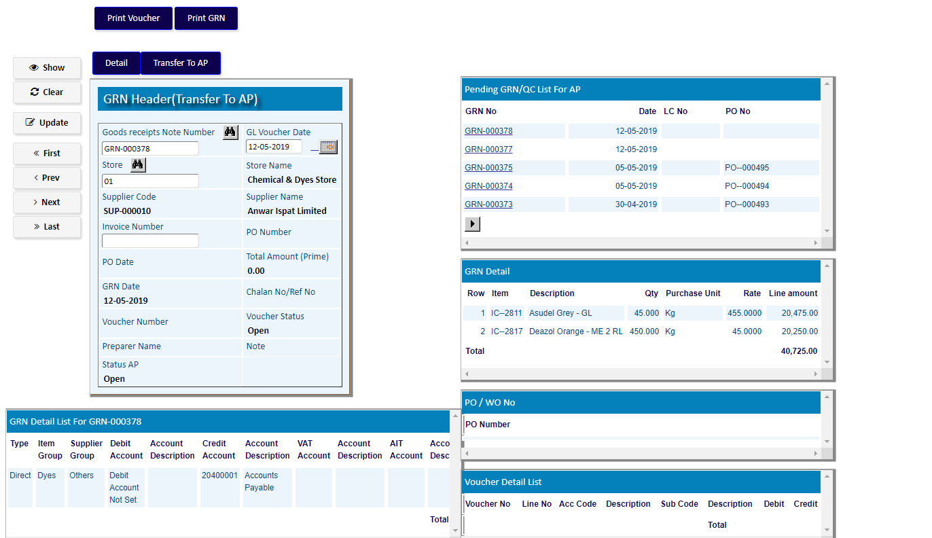

DC009877

# Supplier Payment

|  |  |  |  |
| --- | --- | --- | --- |
| **Step 1** |  |  | Open System **>** Financial Accounts  **>** Accounts Payable > Supplier Payment |
| **Step 2** |  |  | Select a Supplier Number. |
| **Step 3** |  |  | Select Bank, Payment Type, Check, Currency, Amount etc. & then click **Add** |
| **Step 4** |  |  | Click **“Allocate”** to Allocate Invoice for Payment |

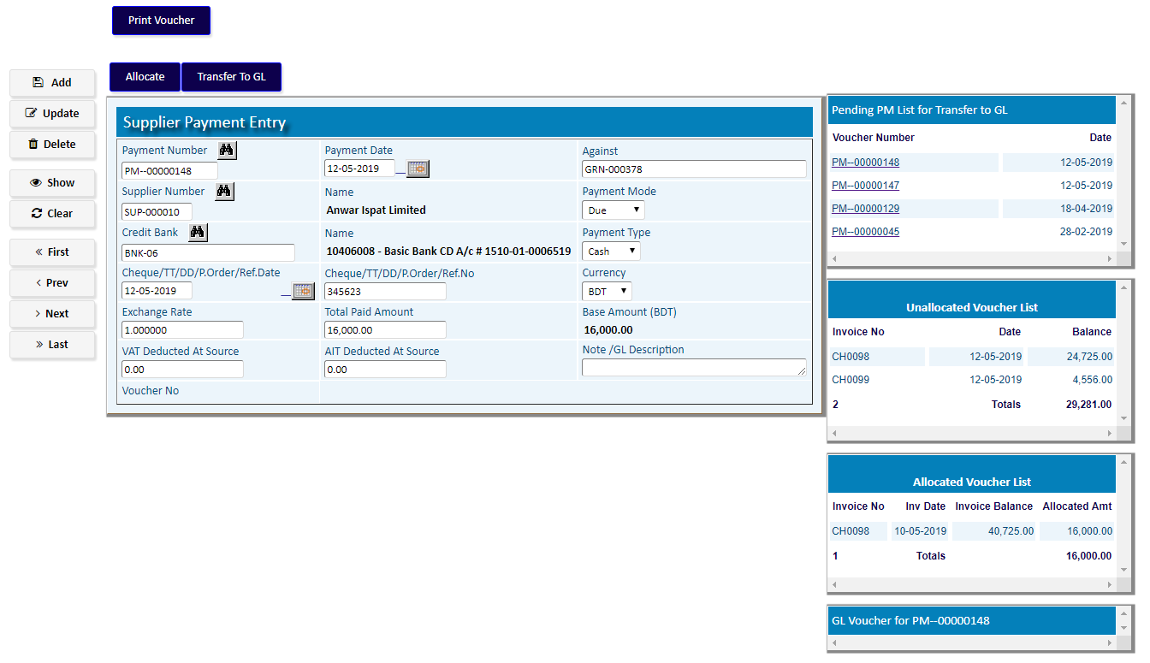

Allocate Invoice for the payment:

1. Select an Invoice Number from the Unallocated Voucher List.
2. Click **Add**
3. Invoice with amount will be allocated
4. After completing allocation, Click **Return**

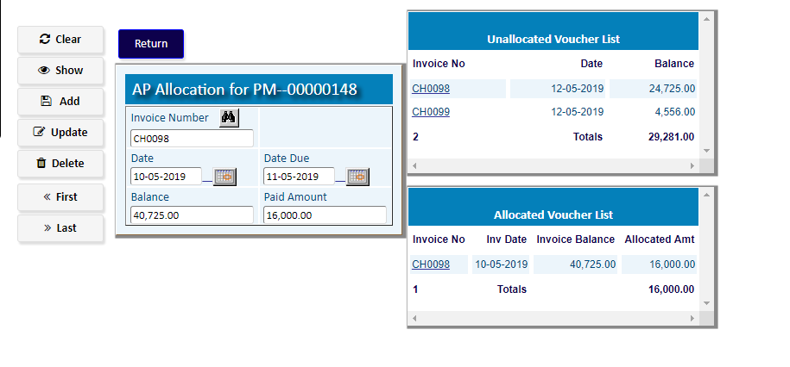

After return to Supplier Payment Entry,

Click **Transfer To GL** for GL transfer.



**After Clicking On Transfer to GL a voucher will be created:**

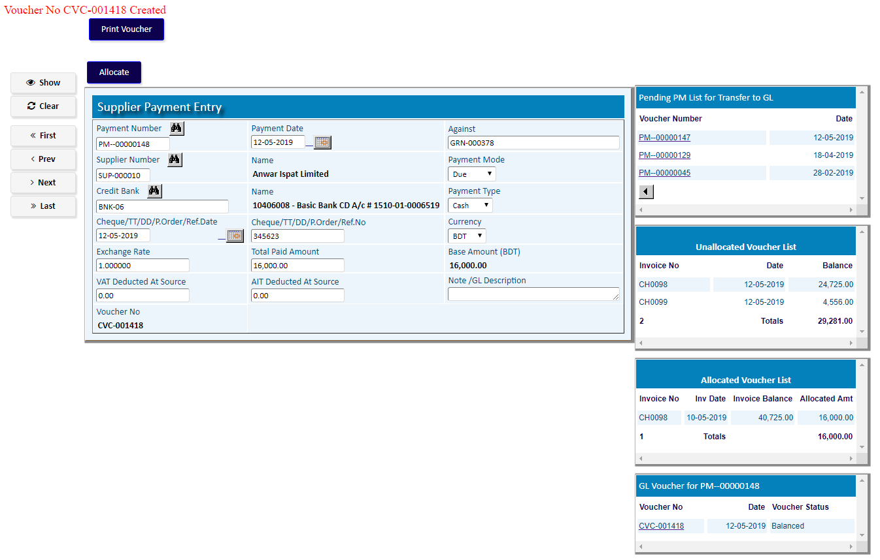

# Reports

## Printing report to preview data

|  |  |
| --- | --- |
| **Step 1** | Open System > Financial Accounts > Accounts Payable **>** Reports |
| **Step 2** | Select a report option. |
| **Step 3** | Select the parameters (from date, to date etc.) to specify data previewing in the report. |
| **Step 4** | Click **“View Report”** to preview in print format. |
| **Result** | The report is previewed in print format. |

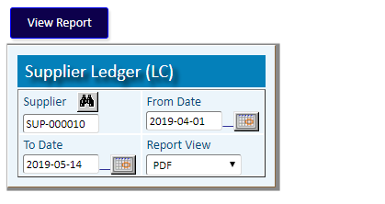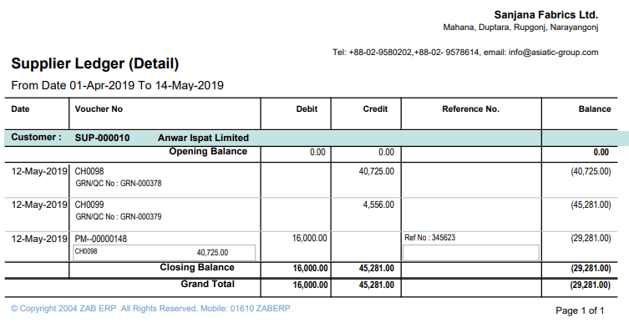

Report Output